Julian Herndon

December 16, 2020 (late)

Foundations of Programing: Python

Assignment 08

<https://github.com/Raphidophyte/IntroToProg-Python-Mod08>

Classes and their Components

Introduction:

This Assignment 08 is over a week late. The goal here is work through the assignment to gain a basic understanding of classes, their components and how they work. This effort and documentation will serve as reference material for my future use. The code submitted here works as required, largely because it was mostly copied from the solution provided by Mr. Root. The conceptual understanding is still useful and instructional.

Asignment08 questions and answers:

1. What is the difference between a class and the objects made from a class?

Answer: A class is like a category or a type. The objects made from the class are data (variables and methods [functions]). In Python everything is technically an object (object-oriented programing). I found a good example of the difference between a class and an object in an example by Prashant Gaur in Quora: Think of a class as a cookie cutter and of the cookies made with the cookie cutter as the objects. For instance, the class might be “cookie” and the object could be “my cookie”.

1. What are the components that make up the standard pattern of a class?

Answer: #-- **Fields** –

# -- **Constructor** –

# -- **Attributes** –

# -- **Properties** –

# -- **Methods** --

1. What is the purpose of a class constructor?

Answer: A class constructor is a special method that runs automatically when you create an object from the class. “__init__” is used to set the initial values of the field. When a new object is made, the “__init__” is called and it passes new arguments made to the “__init__()” method. This is not clear to me…

1. When do you use the keyword "self?"

Answer: To represent the instance of the class. This keyword is used to access the attributes and methods of the class.

1. When do you use the keyword "@staticmethod?"

Answer: When the code that belongs to a class doesn’t use the object itself. This is a concept that I am not entirely sure I understand.

1. How are fields and attributes and property functions related?

Answer: They are all found in a class. From the Mod08 class notes: Fields are members of a class (data), created using variables and constants. Attributes hold data. They are a type of inviable(?) field. Properties are functions used to manage field or attribute data. So, fields are data, attributes hold data and properties manage the field data held in an attribute.

1. What is the difference between a property and a method?

Answer: Properties manage the field data in the attributes, whereas the other functions in a class are called methods. The distinction is on what they work with inside the class.

1. Why do you include a docstring in a class?

Answer: Docstrings are literals that appear right after the definition of a method in triple quotations. They are useful to include in a class to provide additional developer notes that can be displayed in an environment like PyCharm.

1. What is the difference between Git and GitHub?

Answer: Git is a system (platform/program?) to keep track of code and the code history so as to track and archive changes. GitHub is a cloud-based code repository for your code.

1. What is GitHub Desktop?

Answer: GitHub Desktop is an application that can be run on a local computer to work on code version control without needing to connect to GitHub or have access to a browser.

Making the script:

There was not very much “writing of code” for this assignment. The work revolved mostly around trying to understand the answer code key provided by Mr. Root. Slightly less challenging than trying to understand how the code worked, was finding all the mistakes in syntax (~30) that were made while transcribing the code from the answer .pdf to a script I made in PyCharm. This was a useful exercise in learning the correct details of script syntax.

Below are a couple of screen shots, the first of which (Figure 1) shows the script running in PyCharm and demonstrating an error exemption where the user introduced a “$” symbol with the value of the “car”. The second one (Figure 2) shows the script running in the CMD prompt with no associated error (no “$” symbol used) and saving and exiting properly.

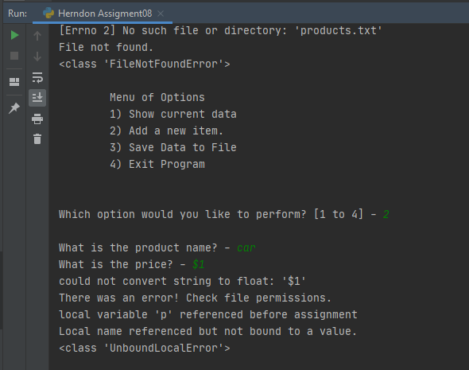

Figure 1: “Herndon Assignment08.py” running in PyCharm.

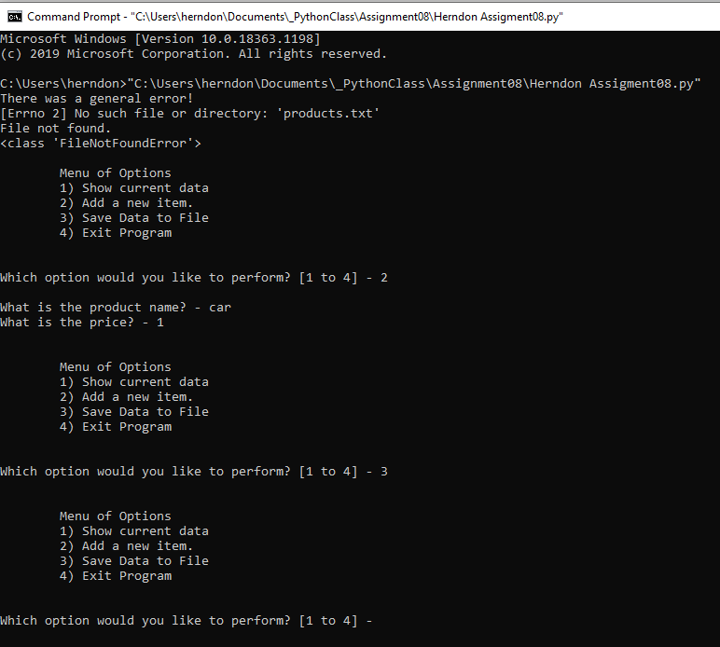

Figure 2: Herndon Assignment07.py” at the CMD prompt.

Summary:

The script runs in both PyCharm and at the CMD prompt. No surprises here. A rudimentary understanding of field, attribute and properties was gained from this exercise and some initial insight into @staticmethod was gained, but I must admit that the purpose and use of this method approach still eludes me.

Note: this assignment was posted to GitHub directly, not by using GirHub Desktop as a lack of administrative privileges requires assistance from IT personnel to load the application to my computer.

References and Resources:

Python.org, (2020). https://docs.python.org/3/library/functions.html

Intro to Programming (Python) Assignment 08. Undated.

https://canvas.uw.edu/courses/1417585/files/67261885?module_item_id=11076747

Root, R. Mod8 Python Programing Notes (undated)

https://canvas.uw.edu/courses/1417585/files/67261884?module_item_id=11076743

Root, R. Mod08 Course Video.

https://www.youtube.com/watch?v=ZnTabY0Z-XE&feature=youtu.be

Starting Assignment 08 Video

https://www.youtube.com/watch?v=Zmgsg6HPxSM&feature=youtu.be

A8AnswerCode.pdf

https://canvas.uw.edu/courses/1417585/files/67261854?module_item_id=11076684